Titanic Dataset – Data Preprocessing Report
Source: Kaggle Titanic train.csv (891 rows, 12 columns). Scope: missing values, categorical encoding, feature scaling and train/test split. No model training.

1. Column Classification
Column | Type | Notes
PassengerId | Identifier | Unique per row, dropped
Survived | Binary (target) | 0 = died, 1 = survived
Pclass | Ordinal | 1 > 2 > 3 (ticket class)
Sex | Binary | male / female
Embarked | Nominal | S, C, Q – no inherent order
Age, Fare | Numerical (continuous) | Different ranges and skew
SibSp, Parch | Numerical (discrete) | Family counts
Name, Ticket, Cabin | Text / high-cardinality | Mostly unique values

2. Missing Values
Column | Missing | Fill value and justification
Age | 177 | Median (28.5). Age is right-skewed, so the median is more robust than the mean.
Cabin | 687 | "Unknown". Noting to guess
Embarked | 2 | Mode (S). Categorical column with only 2 missing rows, so the most frequent port is the safest guess.
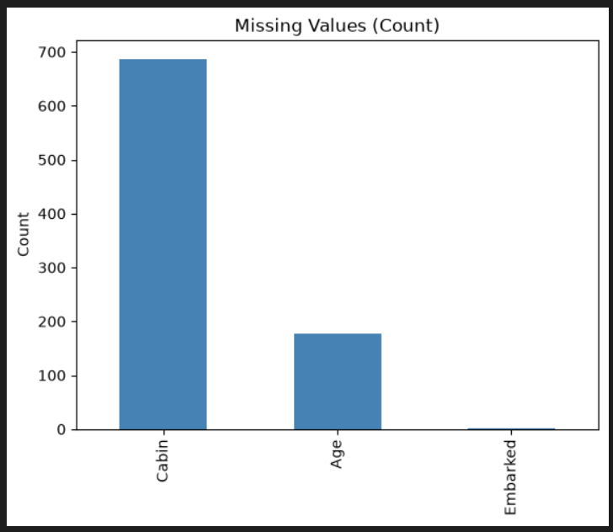
Figure 1: Percentage of missing values per column
The data was split first, and the fill values (Age median, Embarked mode) were computed on the training set only and then applied to both sets, so the test set does not influence preprocessing. No missing values remain afterwards.

3. Categorical Encoding
Variable | Encoding | Reason
Sex | Binary label (male = 0, female = 1) | Only two categories, so a single column is enough.
Embarked | One-hot (3 columns) | Nominal; label encoding would imply a false order S < C < Q.
Cabin | Deck letter, then one-hot (9 columns) | Raw cabin numbers are nearly unique. The first letter gives the deck, and U means Unknown.
Pclass | Kept as 1, 2, 3 | Ordinal; the integer order already reflects the class order.
Name, Ticket, PassengerId | Dropped | High-cardinality text or identifier with no generalisable signal.

4. Feature Scaling
Age, Fare were standardised with StandardScaler (mean 0, standard deviation 1), fitted on the training set only.
- Why needed: the features sit on very different ranges (Fare up to about 512, Age up to 80, Parch up to 6). Distance-based and gradient-based models (KNN, SVM, logistic regression, neural networks) would otherwise be dominated by large-valued features.
- Not scaled: Sex and the one-hot columns (already 0/1) and Pclass (small ordinal range).
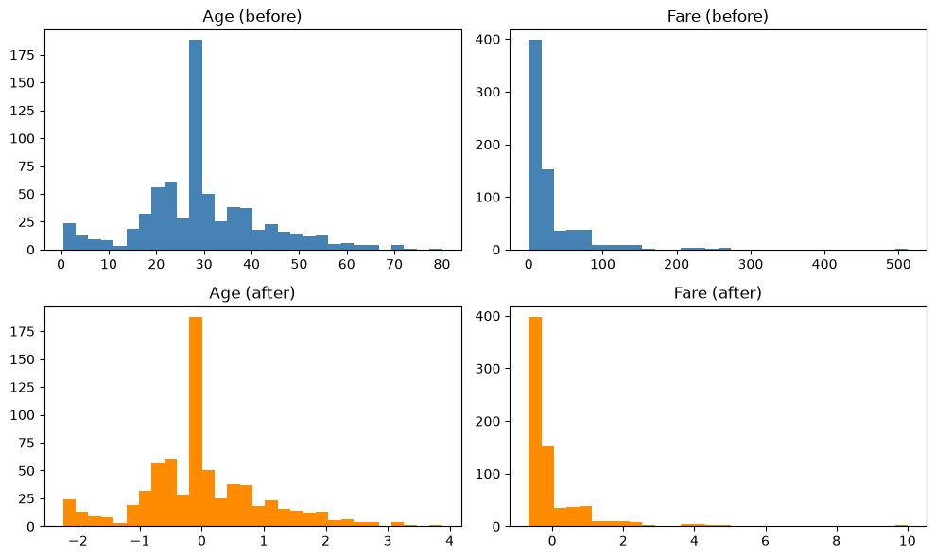
Figure 2: Age and Fare before and after standardisation
The distribution shape is unchanged. Only the scale moves, to a mean of 0 and standard deviation of 1. Fare remains right-skewed; a log transform could be considered for some models but was outside the scope of this task.

5. Train / Test Split and Final Output
- 80 / 20 split with random_state = 42, stratified on Survived to preserve the class ratio (38.3% vs 38.5% survival in train and test).
- X_train: 712 × 18, X_test: 179 × 18, y_train: 712, y_test: 179.
- Final features: Pclass, Sex, Age, SibSp, Parch, Fare, Embarked (C, Q, S)

